Name : Rihhadatul Aisya

Class : XII IPS 3

Study : English

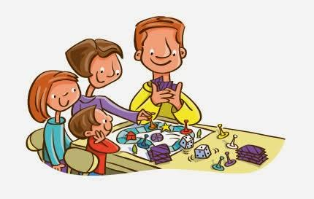

“Children are the key to success in the family.”